**Example: Shortest Path for Messaging**

The mobile social network among students in MGT 40750 is provided in the following diagram,  
where ● represents Female and ■ represents Male.

Question: Find the shortest path from Node _____ to Node _____ through this mobile social network.

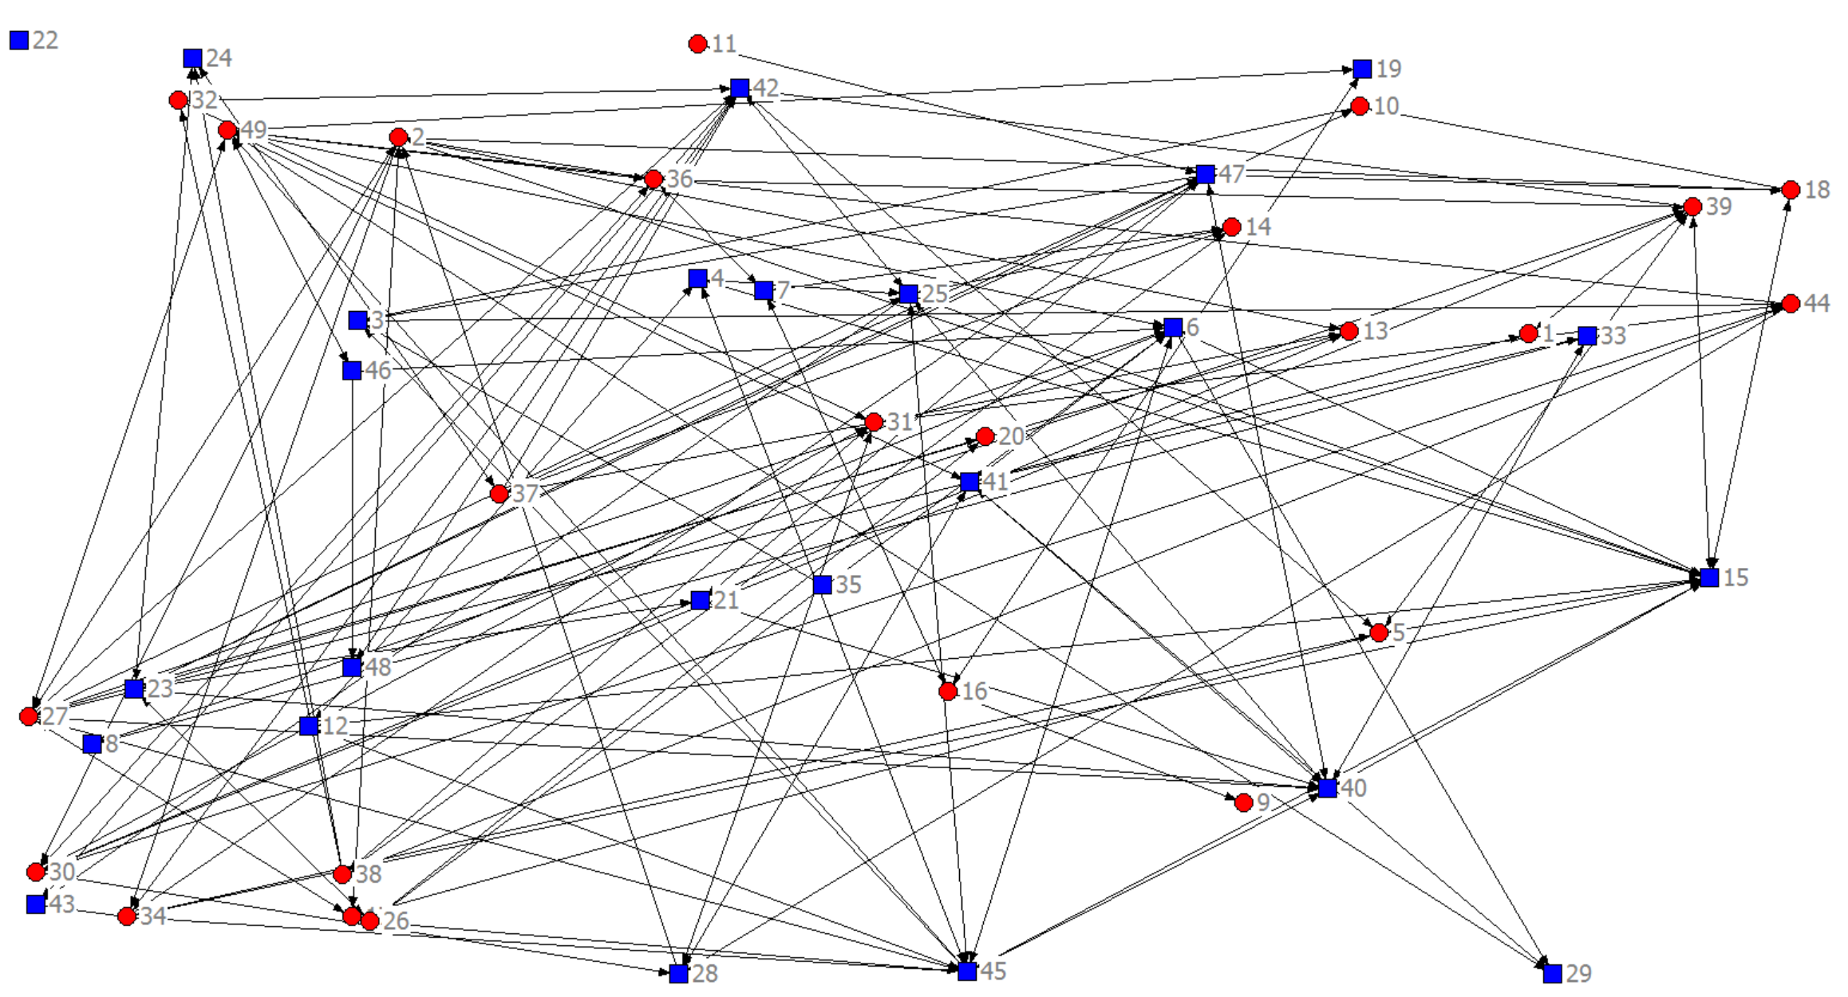

**Shortest Path for Messaging**

**Set up the Shorted Path for Messaging model in Excel: (Start = ___ End = ___)**

|  |
| --- |
|  |
| … |
|  |

**Specify Solver:**

Set Objective: _________

To: ○ Max ○ Min ○ Value of: _________

By Changing Variable Cells: ______________________________________________________

Subject to the Constraints:

|  |
| --- |
|  |

□ Make Unconstrained Variables Non-Negative

Select a Solving Method: ____________

**Solver Results:**

The optimal total distance = _____.